Table of Contents

INTRODUCTION 2

MODULES 3

USER 3

HOME PAGE 3

REGISTER 4

LOGIN 5

DASHBOARD 6

SUBSCRIBE 6

VIEW SUBSCRIPTIONS 7

VIEW NEWSPAPER 8

SUBSCRIPTION HISTORY 10

PROFILE 12

ADMINISTRATOR 13

DASHBOARD 13

SUBSCRIBERS 13

SUBSCRIPTIONS 14

VIEW BY REGION 15

SUBSCRIPTION HISTORY 16

USERS 17

ROLES 18

PROFILE 19

FUTURE MODIFICATIONS 20

DEPLOYMENT 21

REQUIREMENTS 21

INSTALLATION 21

BROWSER SUPPORT 21

LOGIN CREDENTIALS 22

ASSUMPTIONS 22

**NEWPAPER SUBSCRIPTION SYSTEM**

# INTRODUCTION

This system will automate the process of subscribing to a newspaper publication.

# MODULES

These are the classes or entities which are present in the System.

1. USERS
2. CUSTOMER
3. SUBSCRIPTIONS
4. ROLES
5. RECEIPTS

## USER

These will be the people using the system and currently there are two roles. There is a **Customer** and **Administrator** and both use the same login menu as this is a role-based system. Both of these users are redirected to their respective dashboards where a customer will be focusing on subscribing to a publication or publications whereby the admin will be focusing on the roles, users and reports.

### HOME PAGE

To access the home page; run the project and go to the indicated URL if on localhost. You will be presented with a simple screen telling you to Login or Register like below.

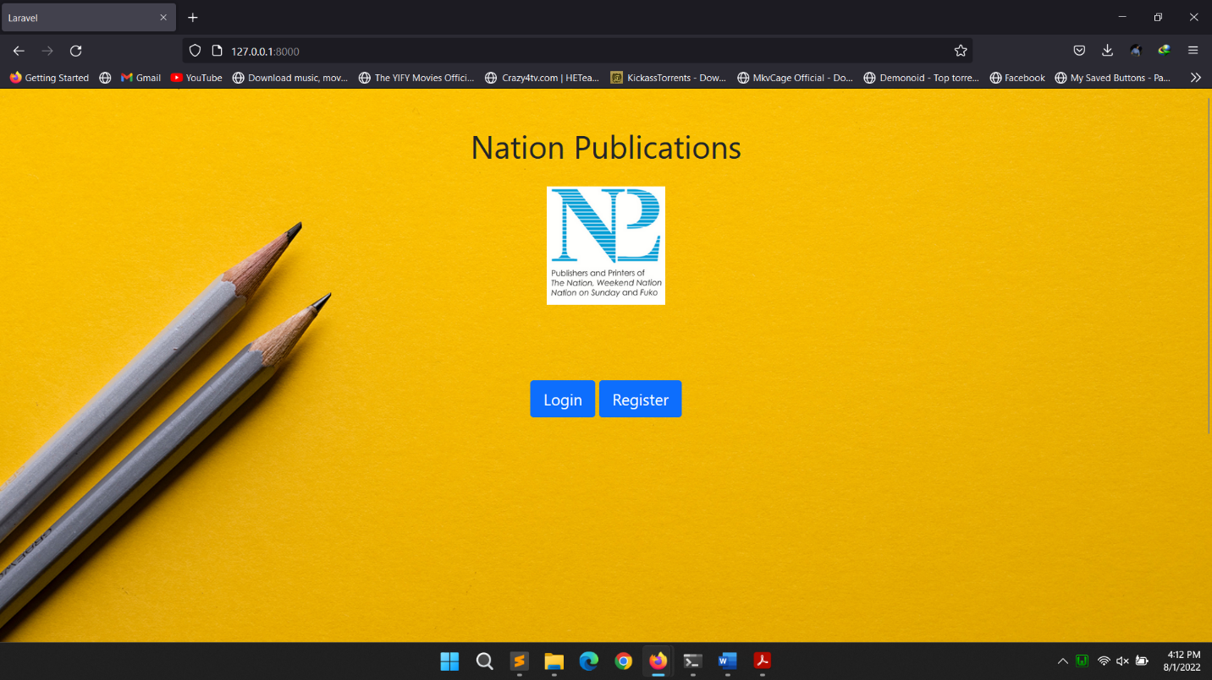

*Figure 1: Home page*

### REGISTER

In order to gain access to the system; you have to be a registered user and in order to register you have to click the **register** button which will take you to the registration page where you will fill all your details including selecting a region and personal information like the image below.

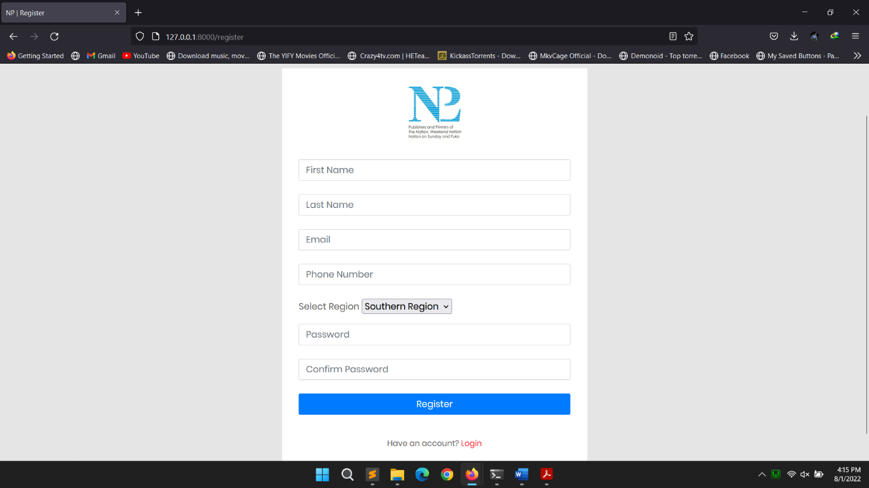

*Figure 2: Register*

### LOGIN

To login into the system and start subscribing to the newspaper you have to first **login** with your **email** and the **password** you used when registering. Navigate to login if after registering you are not logged in automatically then fill your details and click login. Below is the login screen

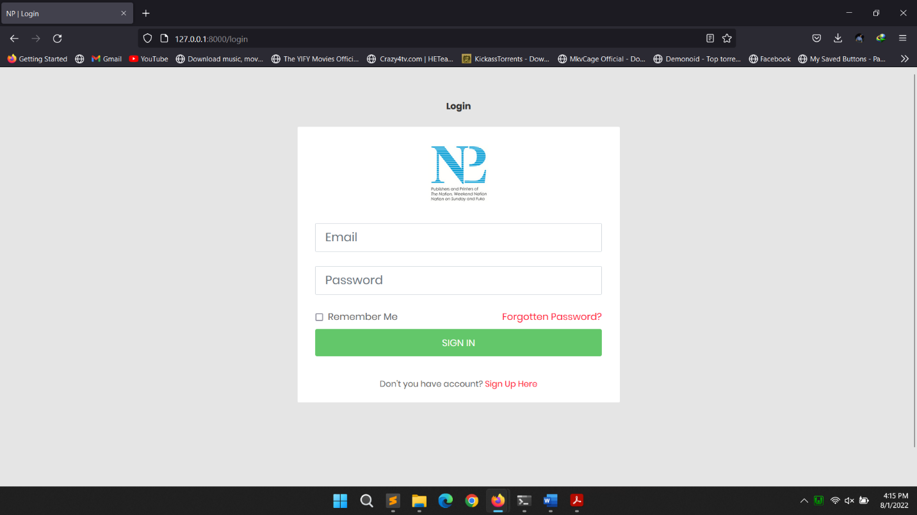

*Figure 3: Login*

### DASHBOARD

After successfully logging in you will be presented with the dashboard. On the left side you will have the navigation menu which will have dashboard, subscriptions and profile. The dashboard is where you currently are. The subscriptions page is where you will be able to subscribe to a publication or publications for chosen months and copies, view your subscriptions, view newspapers per subscription and view your subscription history. You have the right section below the welcome message where you will see the overview of all of your active subscriptions in form of a progress bars and how many days are remaining per subscription. Below is the image of the dashboard.

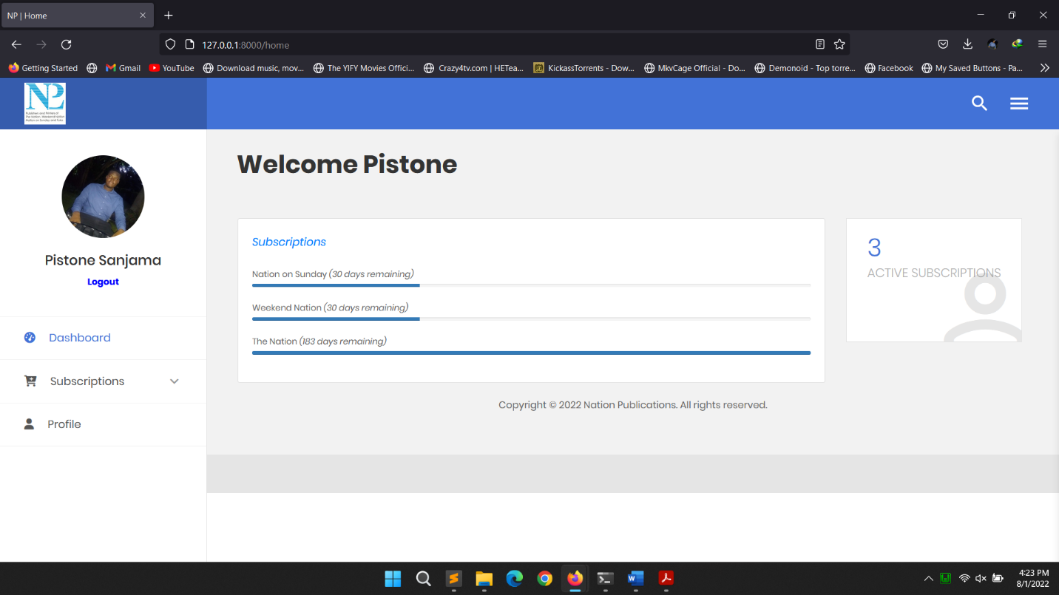

*Figure 4: Dashboard*

### SUBSCRIBE

To be able to view the newspaper for a specific subscription you first have to subscribe by navigating to subscriptions then under subscriptions click **subscribe** where you will be taken to a page where you will have to choose which publication you want from all the three publications. Select the duration and number of copies and click subscribe and you will get a success message saying you have successfully subscribed to the publication and that you can go to newspapers to view per subscribed publication. If you click the subscribe button again on a publication you are already subscribed to, you will be presented with a message saying you are already subscribed to that publication. Below is the image of subscribing to a publication.

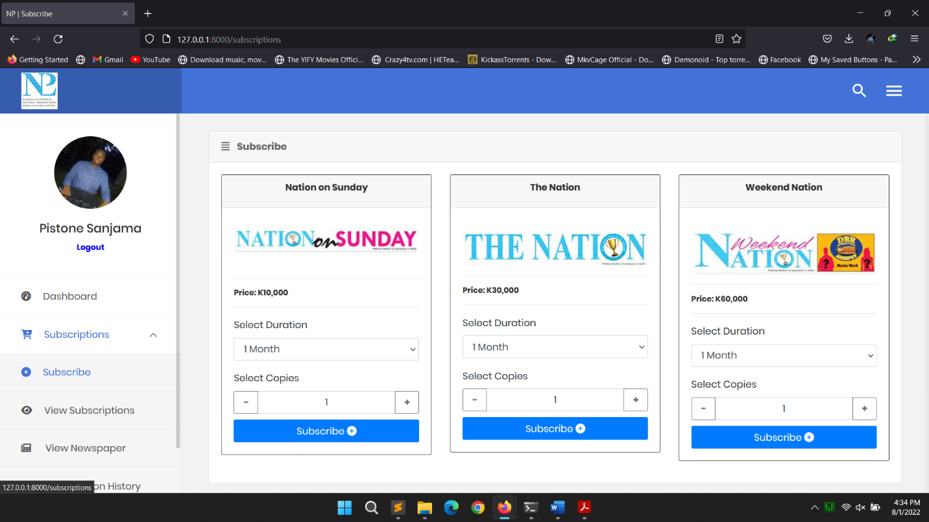

*Figure 5: Subscribing*

### VIEW SUBSCRIPTIONS

To view your active subscriptions, navigate to subscriptions then under subscriptions click **view subscriptions** and you will be taken to a page where you will see an overview of all the subscriptions you are subscribed to and all the necessary information like number of days remaining and subscription dates. Below is the image of viewing subscriptions.

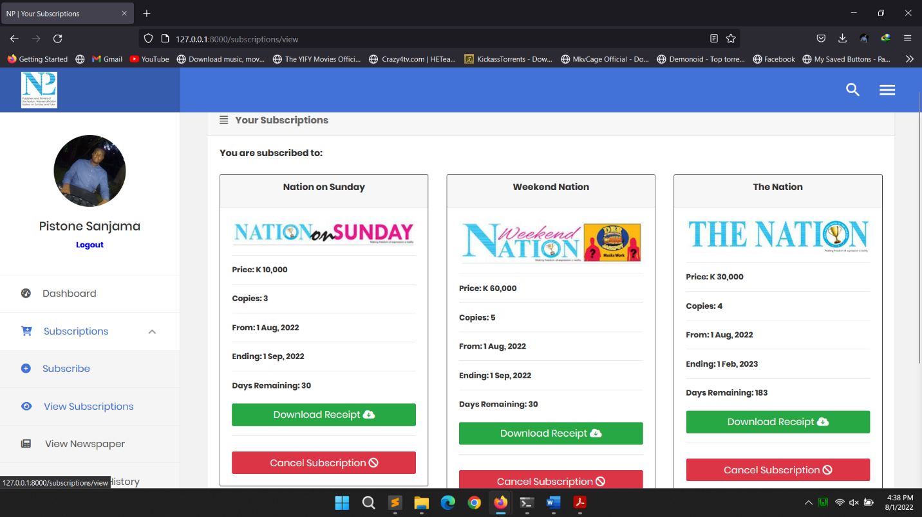

*Figure 6: View subscriptions*

### VIEW NEWSPAPER

I have preserved a similar view to the one you get when subscribing for easy navigation to the end users. To view the newspaper, navigate to subscriptions then under subscriptions click **view newspaper** and you will be taken to a page where you will see all of your active subscriptions where you will have a button on each subscribed publication telling you to view the newspaper from that subscription. If you navigate to this page without a subscription, you will be presented with a message saying You are not subscribed to any publication. Below are the images of viewing subscriptions.

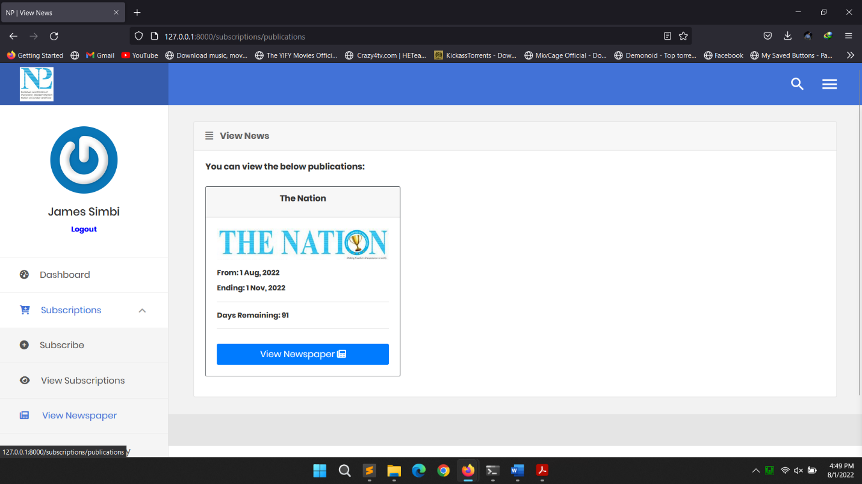

*Figure 7: Selecting subscription with a subscription present*

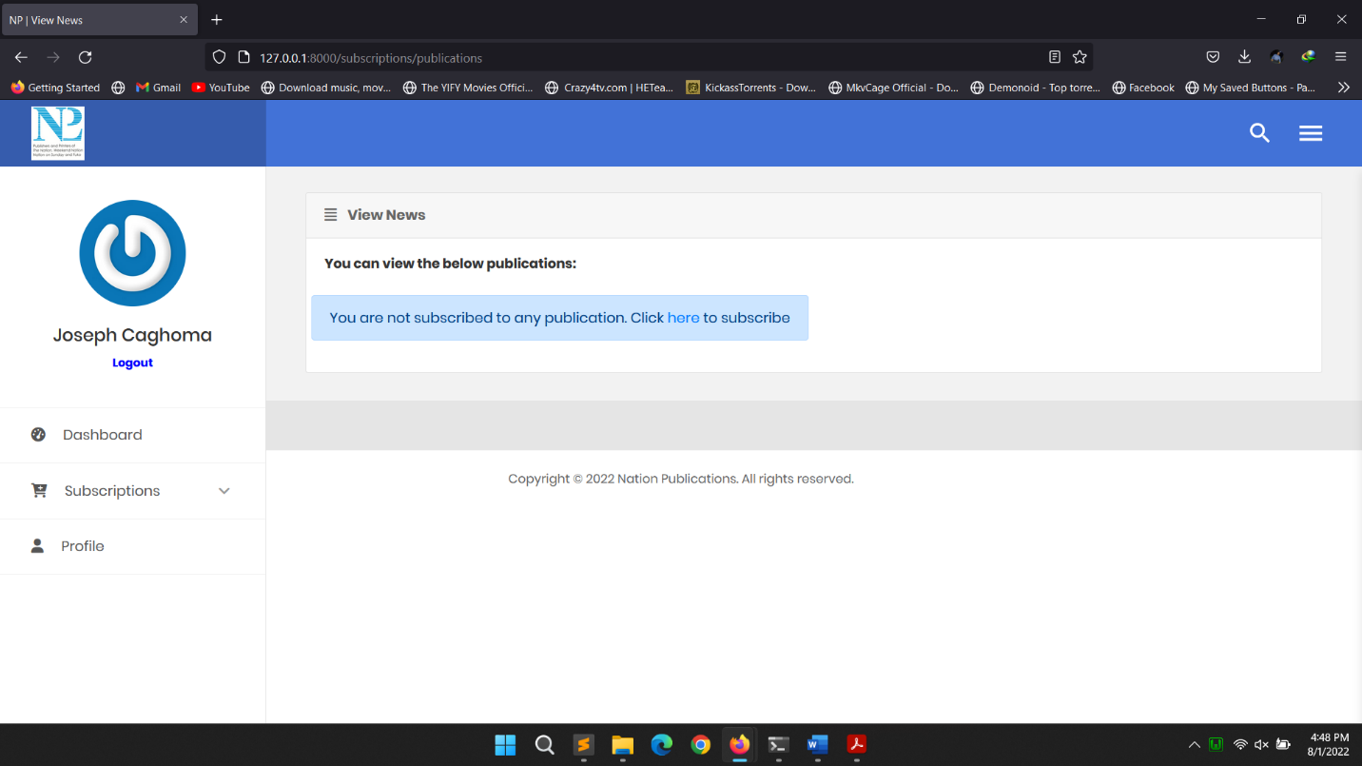

*Figure 8: Selecting subscription without a subscription present*

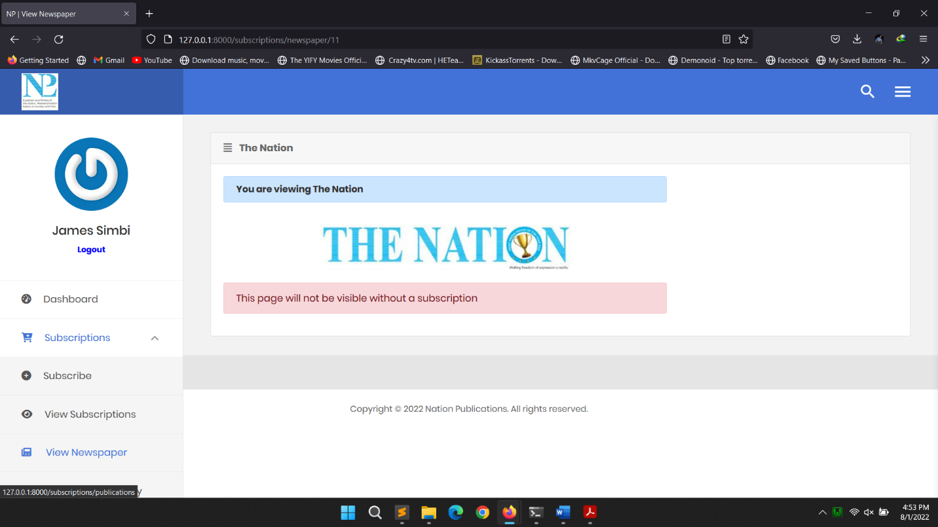

*Figure 9: Viewing newspaper*

### SUBSCRIPTION HISTORY

To view your subscription history, navigate to subscriptions then under subscriptions click **subscription history** and you will be taken to a page where you will see all of your subscriptions including the ones you have cancelled or expired. Here you will be presented with an option to cancel an active subscription or download a receipt of the subscription if it is still active. The receipt comes in the form of a PDF and you can also search using the date and name. The receipt can also be viewed as above there are two buttons one for viewing it and one for downloading it. Below are the images of viewing subscription history together with the receipt information.

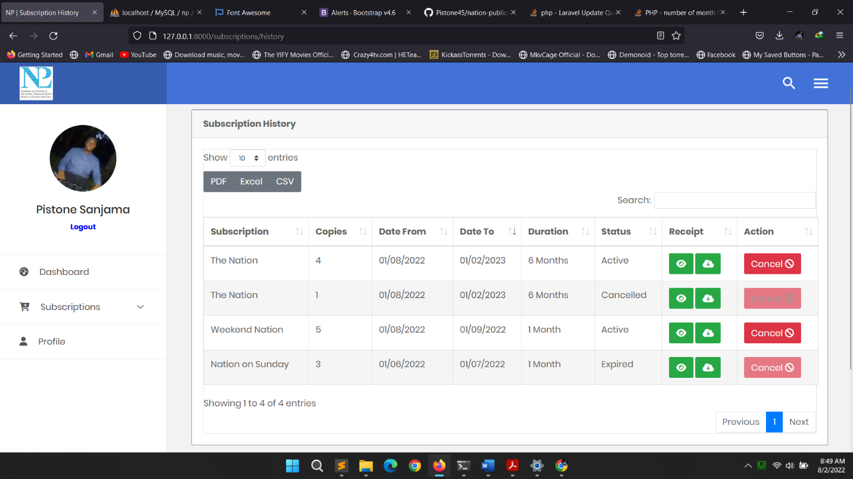

*Figure 10: subscription history*

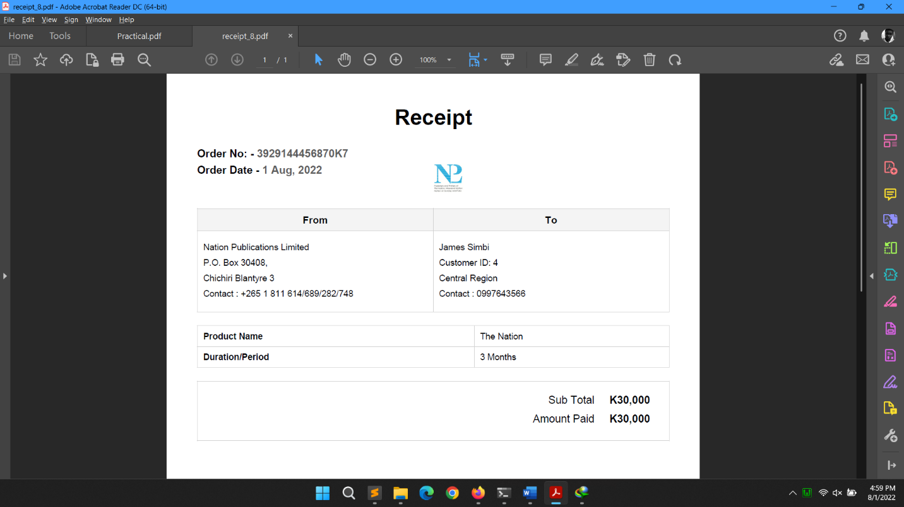

*Figure 11: Receipt in form of a PDF*

### PROFILE

To view your profile, go to the navigation bar and click profile and you will be taken to a page where you will view your basic information. Below is the image of a profile.

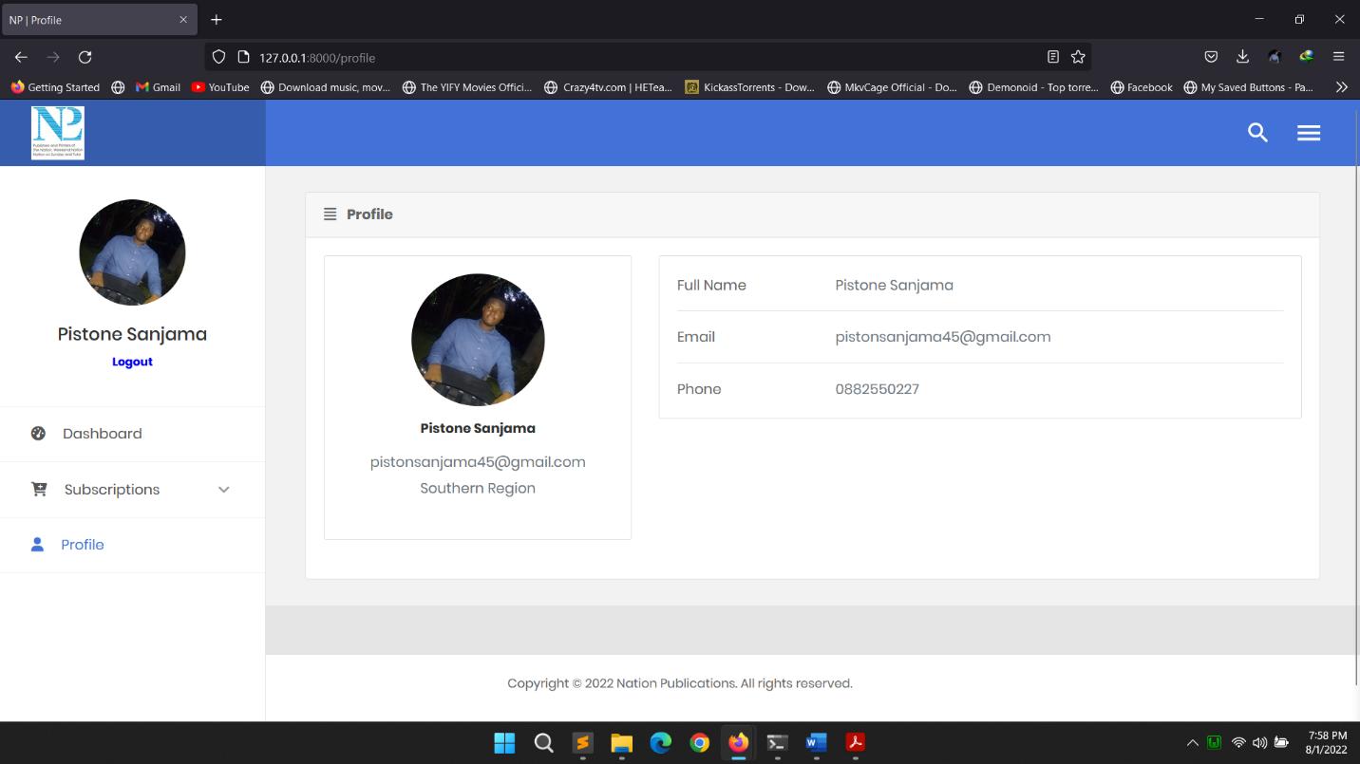

*Figure 12: Profile*

## ADMINISTRATOR

### DASHBOARD

To be presented with the admin dashboard you first have to login using your email and password as the admin. After successfully logging in you will be presented with the dashboard. On the left side you will have the navigation menu which will have dashboard, subscribers meaning the customers, users meaning a combination of the customers and admins, roles and profile. The subscriber’s page is where you will be able to view all of the subscribers with their subscriptions, view subscribers by region and view the subscription history. You also have users on the navigation which will take you to view all the users of the system and then finally a profile where you can see your information. On the right side of the dashboard, we have a system overview, there are banners or cards showing the number of all system users, all active subscriptions counting many from one user, current month subscribers meaning the customers who subscribed that month and the total earnings adding all of the subscriptions and their prices. Below is the image of the dashboard.

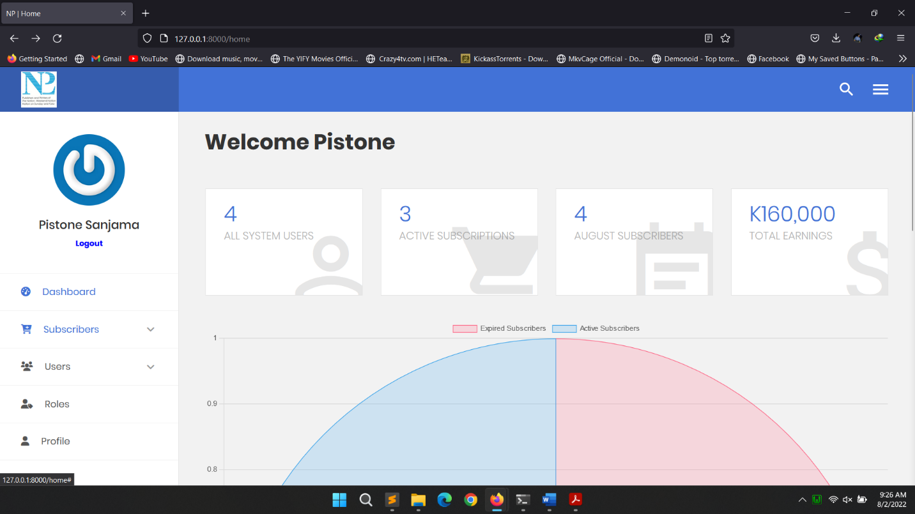

*Figure 13: Admin dashboard*

### SUBSCRIBERS

To view all the subscribers of the system or the users head to the navigation and click on **subscribers** then click **view all** and you will be taken to a page where you view all the subscribers or customers with their region and information. You will also have an option to view each subscribers’ subscriptions by clicking a button which says view. Below is the image of the subscribers.

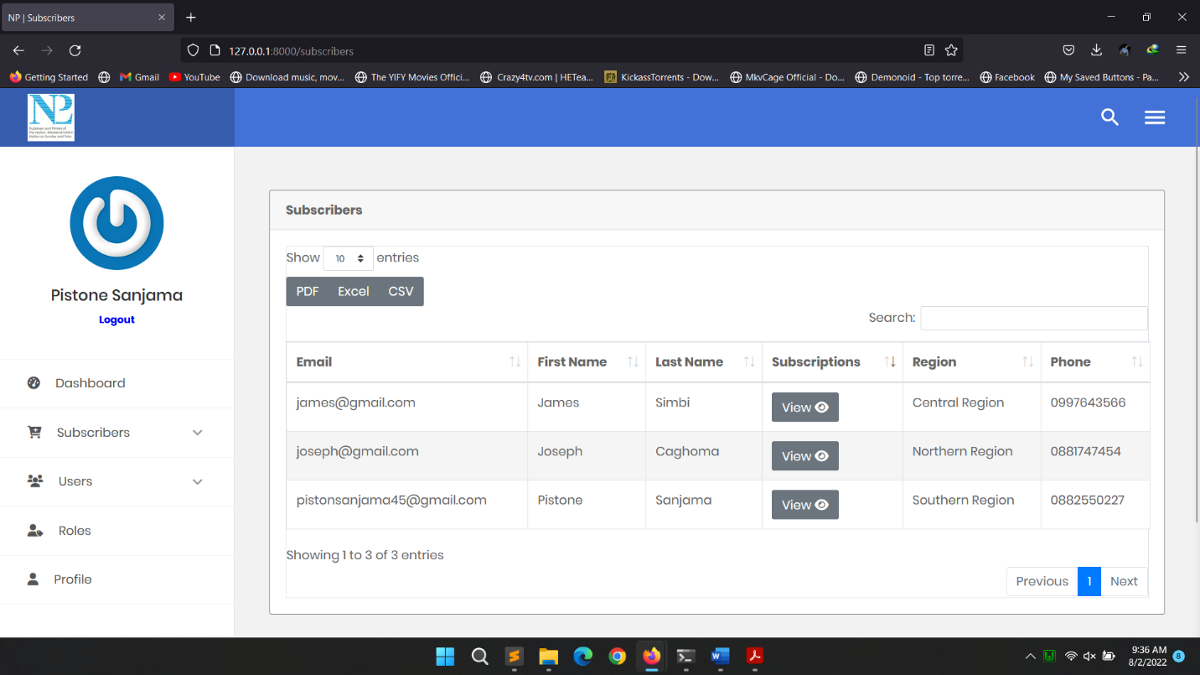

*Figure 14: Subscribers*

### SUBSCRIPTIONS

To view each user’s subscriptions, go to subscribers then click the **view** button. There you will be presented with a page where it will only show the information about the subscriptions. Below is an image.

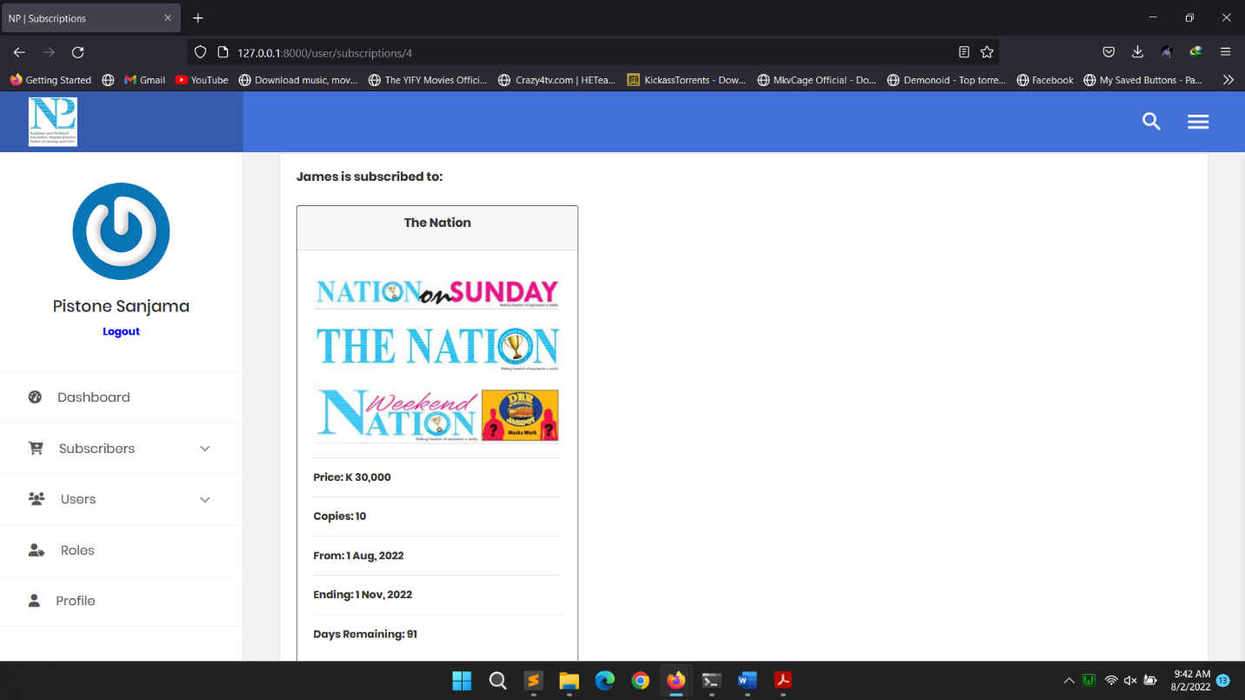

*Figure 15: Users subscriptions*

### VIEW BY REGION

To view all the subscribers of the system or the users head by their regions; go to the navigation and click on **subscribers** then click **view by region**. You will be taken to a page where you will choose all the available regions from a drop down and then click continue to view all the subscribers in that particular region. When viewing the subscribers, you will get a similar view to viewing them all but this time it is tied to a region. Below are the images of the subscribers and selecting the region.

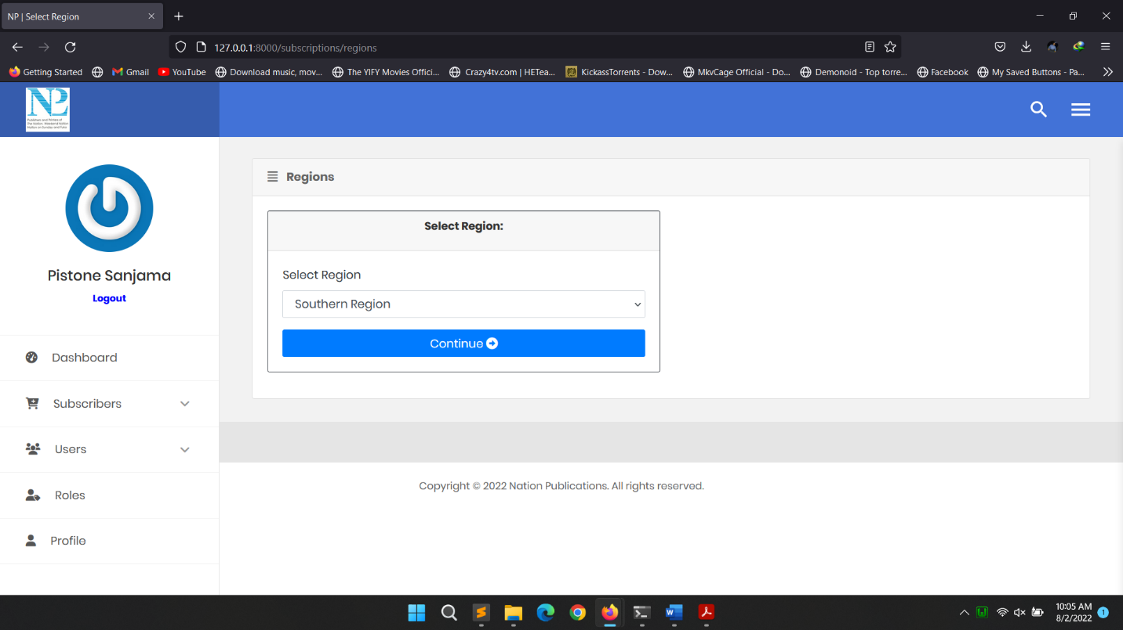

*Figure 16: Selecting region*

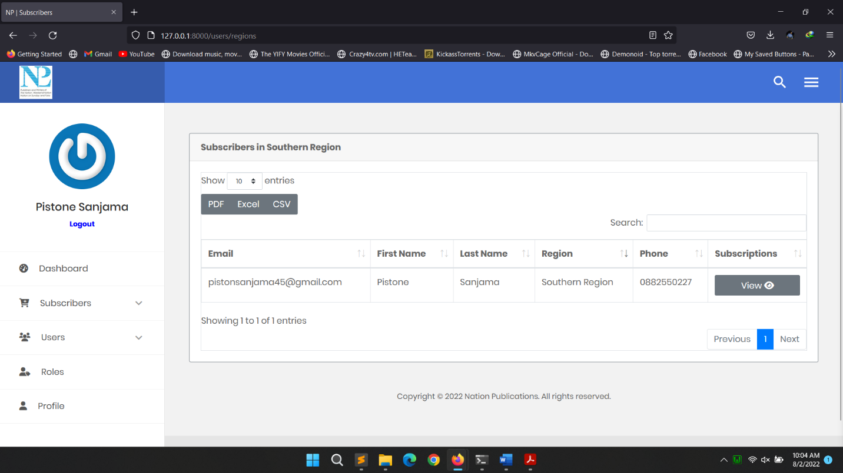

*Figure 17: Viewing subscribers per region*

### SUBSCRIPTION HISTORY

To view all the subscriber’s history or subscriptions in the system; go to the navigation and click on **subscribers** then click **subscription history**. You will be taken to a page where you will see all of the subscriptions present in the system and you can scroll through or search together with the dates and customer information. Below is the image screenshot.

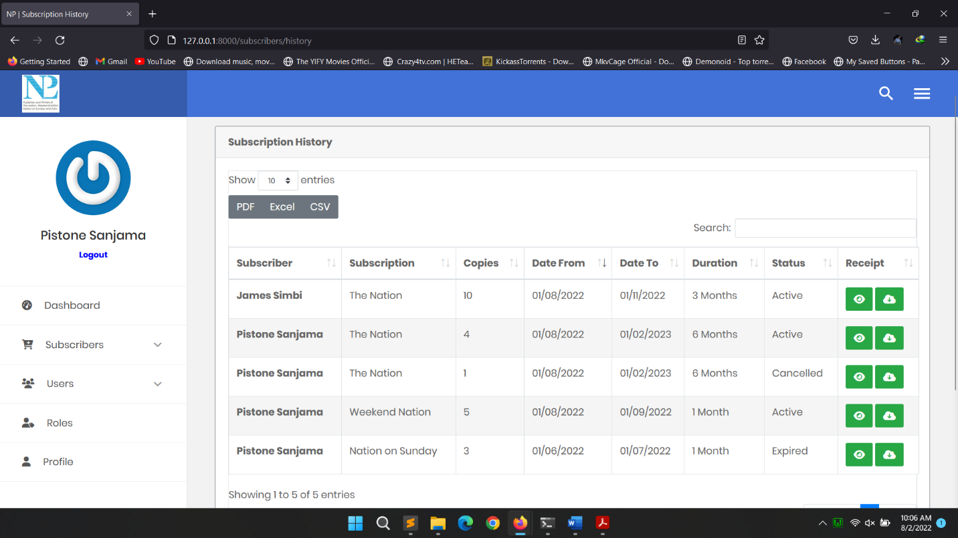

*Figure 18: Subscription history*

### USERS

To view all the users of the system, click **users** on the navigation bar and you will be taken to a page where you will see all the users including yourself together with the role name. For the sake of the less time, I did not implement the actions on the right like change password by sending the password reset link to the user, editing and deleting them. Below is the screenshot.

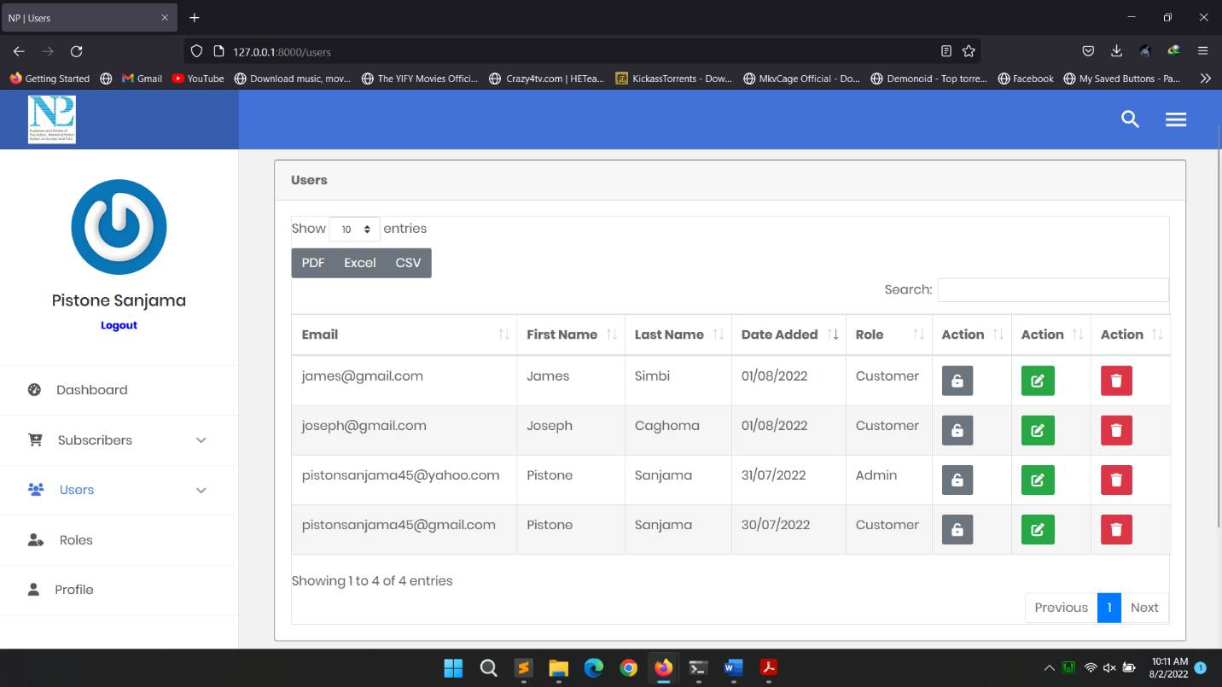

*Figure 19: Users*

### ROLES

To view all the roles in the system, on the navigation bar click roles and you will be taken to a page where you will see all the roles and their descriptions. Here you can add a role, edit and delete a role. Below is the image.

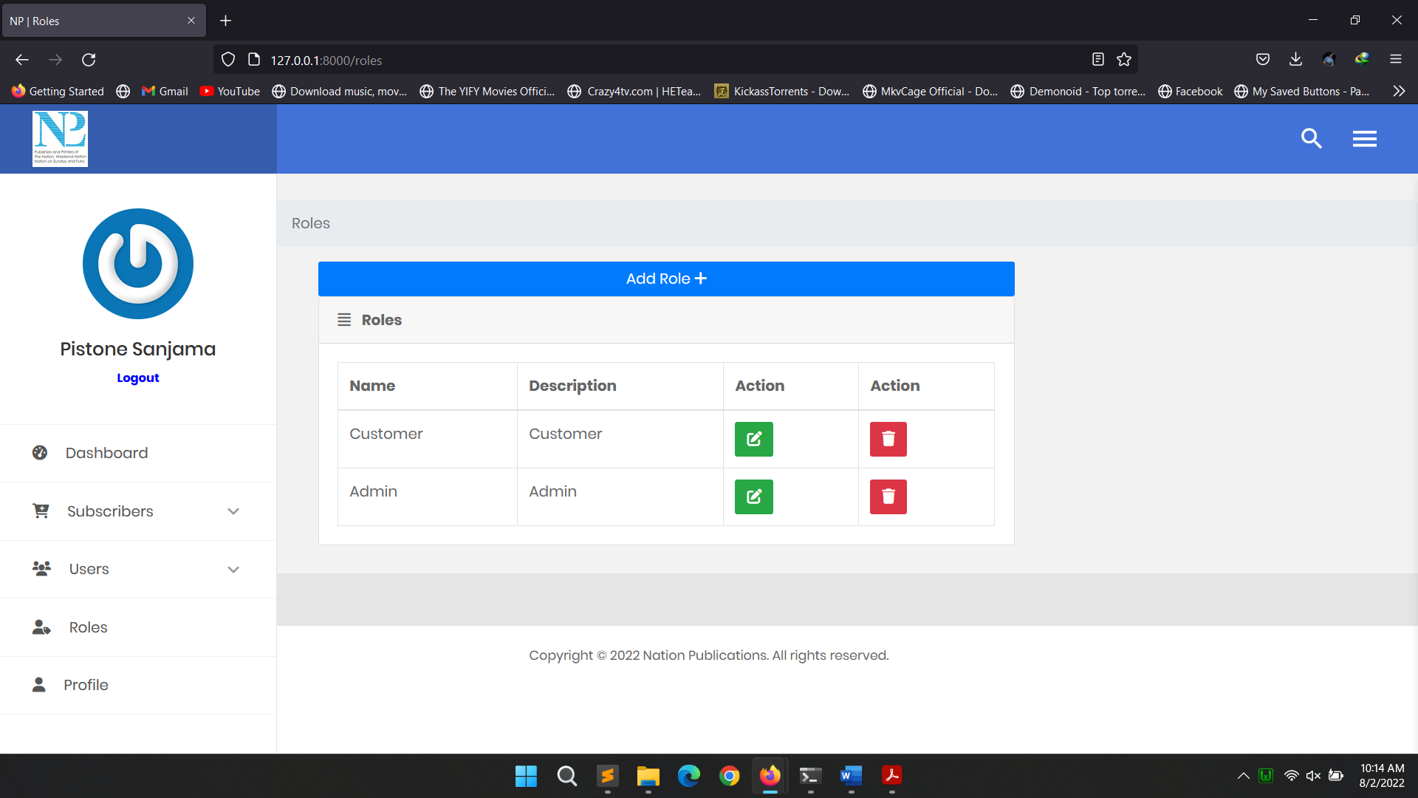

*Figure 20: Roles*

### PROFILE

To view your profile, go to the navigation bar and click profile and you will be taken to a page where you will view your basic information. Below is the image of a profile.

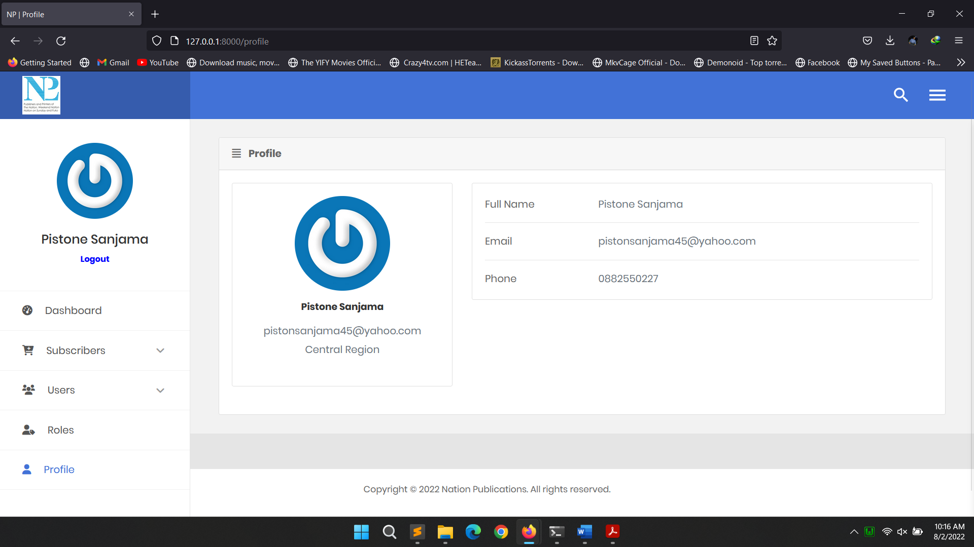

# FUTURE MODIFICATIONS

* Payment system to subscribe to a publication. Mobile services like Airtel Money and Mpamba and Bank services together with using a VISA.
* Multilingual support
* Real time support services
* More content like articles
* Email and SMS notifications about subscription expiry and renewals

# DEPLOYMENT

## REQUIREMENTS

For this project to run the following are required:

* Laravel Version 8*
* MySQL 5.x.x
* Web browser
* Composer using command prompt and artisan

## INSTALLATION

Pull Project from Remote:

* Pull the entire project from (<https://github.com/Pistone45/nation-publications>) to the desired directory.

Using The Command Line:

**Via Git**

* Clone to your machine

**git clone https://github.com/Pistone45/nation-publications.git**

* Install Composer by visiting this link and downloading the installer or use NPM (<https://getcomposer.org/download/>).
* Run composer through command prompt by typing the command composer and then type global require Laravel/installer to install Laravel
* Change the Database connection settings in the env file present in the root folder if you are using a host with a password and a different username
* Navigate to the project root folder and open command prompt or navigate to the root by changing the directory. Type php artisan migrate to migrate all the tables in the selected database
* Navigate to the project root folder and open a command window and type PHP artisan serve to start the server
* Use the displayed server address in any web browser to run the project

## BROWSER SUPPORT

* Google chrome latest version
* Mozilla Firefox latest version
* Safari latest version
* Internet Explorer 10+
* Opera latest version
* Microsoft Edge latest version

## LOGIN CREDENTIALS

The following are the default credentials present by default:

***The password for all default users is pistone45***

* [pistonsanjama45@gmail.com](mailto:pistonsanjama45@gmail.com) Customer
* [pistonsanjama45@yahoo.com](mailto:pistonsanjama45@yahoo.com) Admin
* [James@gmail.com](mailto:James@gmail.com) Customer
* [joseph@gmail.com](mailto:joseph@gmail.com) Customer

# ASSUMPTIONS

1. We will not have actual newspapers in the system rather a page which will be shown to the user when they are subscribed to a publication and this page will not show if no subscription is present.
2. A System has to have roles so I have made two roles, Admin and Customer/Subscriber whereby the admin will be seeing the system functions and the user subscribing to the newspapers.
3. I have included a search on all pages where I am bringing in data from the database. This search is server side meaning that even if we have thousands on records on the system, it will not affect performance of the system no matter how small the device using the system is and it is well optimized. You can search anything and it appear.
4. I have made reports both showing as a graph and as data in a table
5. I have made all the data coming in the form of tables downloadable in PDF, EXCEL format and CSV formats.
6. I have integrated gravatar, a service which fetches an image of an email and displays it or else there will be a placeholder image.
7. The system is not asking for a payment rather a customer will just subscribe for a publication for a given time period and I have simulated the viewing of newspapers. After this given time period ends; You will no longer access the page unless you subscribe again.
8. I have included the total earnings and current month subscribers
9. I have made a receipt downloadable showing the amount of the publication and information, customers information and Nation Publications logo